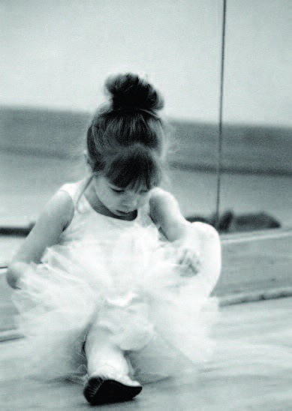

6 Week Session
Jan 22nd-Feb 8th
Wed 10:45-11:30am
$80

Register online at www.DANCEatADA.com

WEE DANCE!
Our WEE Dance is for Mommy (or Daddy/ caregiver and me) and is designed to help aid in the development of skills appropriate for a 2 year old. For this reason our class uses a parent or caregiver to help us orient the child into a classroom setting encouraging the development of fine and gross motor skills. These skills are developed through the use of music, dance, and support of those who love them. Along with assisting in the development of motor skills in the children we incorporate sharing, taking turns, and following directions. These aspects all lead to the development of socialization and additional necessary skills of listening and memory.

Frequently Asked Questions:
Does my child need to be potty trained? Potty training is not necessary because parents are in the room. When they move to a PS1 class we like them to be potty trained and it is a great way to encourage them to achieve this goal so that they can dance in a "big kid" 3 -4 year old class.
What should my child wear?
Leotards are encouraged for girls and boys should wear athletic pants and a tshirt. Bare feet or ballet slippers are to be worn. As for parents, dress comfortably and be prepared to remove your shoes as street shoes are not permitted on our special floating hardwood floors.
What if my child gets upset? The reason we have parents in the room with the dancers is to help them feel comfortable as they move into this wonderful developmental phase of the pre-school age. Your dancer may sit on your lap and you may assist them in any manner. We do ask that if your child has not calmed down after a bit that you take them into the waiting room for a little break to help them relax.
I have twins-what do I do? Don't worry, a teacher will help one of them each week.
I have an infant-what do I do? Don't worry, a teacher will help your child if your need to tend to the baby. We have found that most babies enjoy to listen and watch!
What can a 2 year old really learn? After many years of working with young children, I have found that children retain more than we think! Many young dancers do not do much in the classroom but can go home and teach a sibling, or a doll, the whole class. In a fun and educational setting these dancers will begin to learn the basics of dance through developing their fine and gross motor skills. They will learn skills such as to jumping two footed, one footed, skipping, galloping and marching. They will develop a sense of musicality and learn many new songs. They will learn to take turns and work with other children. Most importantly, they will learn to follow directions and have fun while learning. These are all skills needed as they progress not only in dance but in life.

